Project Report

On

TOURISM

MANAGEMENT SYSTEM

ABSTRACT

As the name specifies “TOURISM MANAGEMENT SYSTEM” is software developed for managing tour booking.

Identification of the drawbacks of the existing system leads to the designing of computerized system that will be compatible to the existing system with the system which is more user friendly and more GUI oriented. We can improve the efficiency of the system, thus overcome the drawbacks of the existing system.

- Less human error

- Strength and strain of manual labour can be reduced

- High security

- Data redundancy can be avoided to some extent

- Data consistency

- Easy to handle

- Easy data updating

- Easy record keeping

- Backup data can be easily generated

INDEX

- Objective
- Existing System
- Proposed System
- Study of the System
- Functional Requirements
- System Environment
- SDLC Methodology
- UML Diagram
- Entity-Relationship Diagrams
- Database Design
- Normalization
- Architecture Flow (N-Tier)
- Output Screen of Project
- Conclusion
- Bibliography

OBJECTIVE:
- The objective of the project is to develop a system that automates the processes and activities of a travel and tourism agency.
- The purpose is to design a system using which one can perform all operations related to traveling and sight-seeing.

EXISTING SYSTEM:
- In the present system a customer has to approach various agencies to find details of places and to book tickets.
- This often requires a lot of time and effort.
- A customer may not get the desired information from these offices and often the customer may be misguided.
- It is tedious for a customer to plan a particular journey and have it executed properly.

PROPOSED SYSTEM:
- The proposed system is a web based application and maintains a centralized repository of all related information.
- The system allows one to easily access the relevant information and make necessary travel arrangements.
- Users can decide about places they want to visit and make bookings online for travel and accommodation.

STUDY OF THE SYSTEM:
To provide flexibility to the users, the interfaces have been developed that are accessible through a browser. The GUI’S at the top level have been categorized as
- Administrative user interface
- The operational or generic user interface

The ‘administrative user interface’ concentrates on the consistent information that is practically, part of the organizational activities and which needs proper authentication for the data collection. These interfaces help the administrators with all the transactional states like Data insertion, Data deletion and Date updation along with the extensive data search capabilities.

The ‘operational or generic user interface’ helps the end users of the system in transactions through the existing data and required services. The operational user interface also helps the ordinary users in managing their own information in a customized manner as per the included flexibilities.

FUNCTIONAL REQUIREMENTS:

Number of Modules
After careful analysis the system has been identified to have the following modules:

- Administrator module
- User(Traveler) module
- Guest user

1. ADMINISTRATOR MODULE:
This module provides administrator related functionality. Administrator manages all information and has access rights to add, delete, edit and view the data related to places, travels, routes, bookings, Enquiries etc.
Packages—Admin will create the packages and Manage the packages (Create, Update, delete)
Users- Admin views all Information of all users.
Booking- Admin will responsible for manage booking. Admin can confirm and cancel a booking of traveler.
Manage issues/ Complaints—Admin can take action on any issue /complaint raised by user (traveler) and Put remark.
Manage Enquiries—admin can manage all enquiries raised by users (traveler).
Manage pages- Admin can edit the info of all pages that are display on the website,
Dashboard- Here admin can view all count of booking, issues, Enquiries and Users.
Change password--- Admin can change own password.

2. USER (TRAVELLER) MODULE:
Signup- User can register yourself for booking.
Sign in- Here user can login with valid username and password.
Forgot Password—User can recover his/her own password.
My Profile- user can update own profile.
Tour history-After login user can book any tour that will show in Tour history. User can cancel his/her booking before 24 hr of travelling.
Change Password---- User can own Password.
Write-use—here user can raise any issue related to booking. Cancelation etc.
3.Guest MODULE:
Guest user can visit the website and view the all content of website. Guest user can also Enquiry.

SYSTEM ENVIRONMENT

2.1 Hardware Configuration

- Pentium IV Processor

- 512 MB RAM

- 40GB HDD

- 1024 * 768 Resolution Color Monitor

Note: This is not the “System Requirements”.

2.2 Software Configuration

1. OS : Windows XP

2.PHP Triad (PHP5.6, MySQL, Apache, and PHPMyAdmin)

2.3 Software Features

2.3.1 PHP TRIAD

PHPTriad installs a complete working PHP/MySQL server environment on Windows platforms (9x/ NT). Installs PHP, MySQL, Apache, and PHPMyAdmin.

2.3.1.1 PHP

PHP (Hypertext Preprocessor) is a widely-used open-source server-side scripting language designed primarily for web development. It was originally created by Danish-Canadian programmer Rasmus Lerdorf in 1994 and has since been continuously developed by a large community of developers.
PHP is particularly well-suited for creating dynamic web pages and web applications. It can generate dynamic content, interact with databases, handle forms, manage sessions, create cookies, and perform many other tasks necessary for web development. PHP code is usually embedded directly into HTML documents, allowing developers to mix PHP code with HTML seamlessly.
2.3.1.1.1 Syntax

<html>

<head>

<title>PHP Test </title>

</head>

<body>

<?php echo “<p> Hello World </p>”; ?>

</body></html>

2.3.1.2 MY SQL

MySQL is a multithreaded,multi-user SQL database management system(DBMS). The basic program runs as a server providing multi-user access to a number of databases.Originally financed in a similar fashion to the JBoss model, MySQL was owned and sponsored by a single for-profit firm, the Swedish company MySQLAB now a subsidiary of Sun Microsystem , which holds the copyright to most of the codebase. The project’s source code is available under terms of the GNU General Public Licence, as well as under a variety of proprietory agreements.

MySQL is a database.The data in MySQL is stored in database objects called tables.A table is a collections of related data entries and it consists of columns and rows.Databases are useful when storing information categorically. A company may have a database with the following tables: “Employees”, “Products”, “Customers” and “Orders”.

2.3.1.2.1 Database Tables

A database most often contains one or more tables. Each table is identified by a name (e.g. “Customers” or “Orders”). Tables contain records (rows) with data.

2.3.1.2.2 Queries

A query is a question or a request.WithMySQL, we can query a database for specific information and have a recordset returned.

2.3.1.2.2.1 Create a connection to a database

Before you can access data in a database, you must create a connection to the database.In PHP, this is done with the mysqli_connect() function.

Syntax

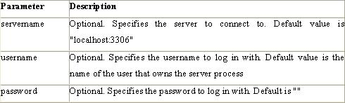
mysqli_connect (servername,username,password);

2.3.1.2.2.2 Closing a Connection

The connection will be closed automatically when the script ends. To close the connection before, use the mysqli_close() function:

<?php

//database connection

$con=mysqli_connect("localhost","root","","preschooldb");

if(mysqli_connect_errno()){

echo "Connection Fail".mysqli_connect_error();

}

?>

2.3.1.2.2.3 Create a Database

The CREATE DATABASE statement is used to create a database in MySQL.

Syntax

CREATE DATABASE database_name

To get PHP to execute the statement above we must use the mysql_query() function. This function is used to send a query or command to a MySQL connection.

2.3.1.2.2.4 Create a Table

The CREATE TABLE statement is used to create a table in MySQL

Syntax

CREATE TABLE table_name

(
column_name1 data_type, column_name2 data_type, column_name3 data_type,

..

2.3.1.4 phpMAdmin

phpMyAdminis an open source tool written in PHP intended to handle the administration of MySQLover the World Wide Web. phpMyAdmin supports a wide range of operations with MySQL.Currently it can create and drop databases, create/drop/alter tables, delete/edit/add fields, execute any SQL statement, manage users and permissions, and manage keys on fields. while you still have the ability to directly execute any SQL statement. phpMyAdmin can manage a whole MySQL server (needs a super-user) as well as a single database. To accomplish the latter you’ll need a properly set up MySQL user who can read/write only the desired database. It’s up to you to look up the appropriate part in the MySQL manual

SDLC Methodology:
This document play a vital role in the development of life cycle (SDLC) as it describes the complete requirement of the system. It means for use by developers and will be the basic during testing phase. Any changes made to the requirements in the future will have to go through formal change approval process.
SPIRAL MODEL was defined by Barry Boehm in his 1988 article, “A spiral Model of Software Development and Enhancement. This model was not the first model to discuss iterative development, but it was the first model to explain why the iteration models.
As originally envisioned, the iterations were typically 6 months to 2 years long. Each phase starts with a design goal and ends with a client reviewing the progress thus far. Analysis and engineering efforts are applied at each phase of the project, with an eye toward the end goal of the project.
The steps for Spiral Model can be generalized as follows:
- The new system requirements are defined in as much details as possible. This usually involves interviewing a number of users representing all the external or internal users and other aspects of the existing system.
- A preliminary design is created for the new system.
- A first prototype of the new system is constructed from the preliminary design. This is usually a scaled-down system, and represents an approximation of the characteristics of the final product.
- A second prototype is evolved by a fourfold procedure:
- Evaluating the first prototype in terms of its strengths, weakness, and risks.
- Defining the requirements of the second prototype.
- Planning an designing the second prototype.
- Constructing and testing the second prototype.
- At the customer option, the entire project can be aborted if the risk is deemed too great. Risk factors might involved development cost overruns, operating-cost miscalculation, or any other factor that could, in the customer’s judgment, result in a less-than-satisfactory final product.
- The existing prototype is evaluated in the same manner as was the previous prototype, and if necessary, another prototype is developed from it according to the fourfold procedure outlined above.
- The preceding steps are iterated until the customer is satisfied that the refined prototype represents the final product desired.
- The final system is constructed, based on the refined prototype.
- The final system is thoroughly evaluated and tested. Routine maintenance is carried on a continuing basis to prevent large scale failures and to minimize down time.
The following diagram shows how a spiral model acts like: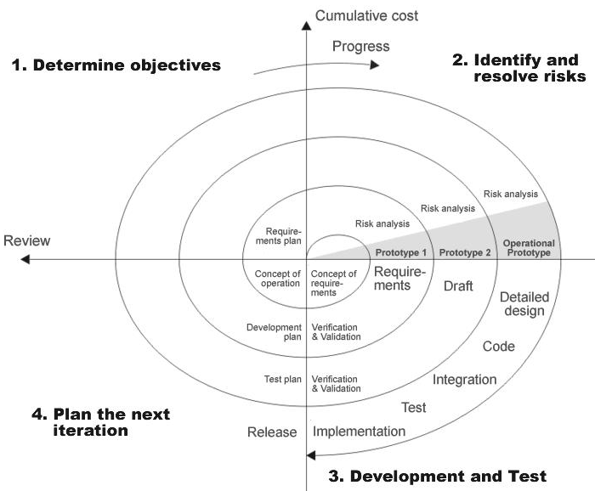

Advantages:
- Estimates(i.e. budget, schedule etc .) become more relistic as work progresses, because important issues discoved earlier.
- It is more able to cope with the changes that are software development generally entails.
Software engineers can get their hands in and start woring on the core of a project earlier

Performance Requirements:
Performance is measured in terms of the output provided by the application. Requirement specification plays an important part in the analysis of a system. Only when the requirement specifications are properly given, it is possible to design a system, which will fit into required environment. It rests largely with the users of the existing system to give the requirement specifications because they are the people who finally use the system. This is because the requirements have to be known during the initial stages so that the system can be designed according to those requirements. It is very difficult to change the system once it has been designed and on the other hand designing a system, which does not cater to the requirements of the user, is of no use.
The requirement specification for any system can be broadly stated as given below:
- The system should be able to interface with the existing system
- The system should be accurate
- The system should be better than the existing system
The existing system is completely dependent on the user to perform all the duties.

UML Diagram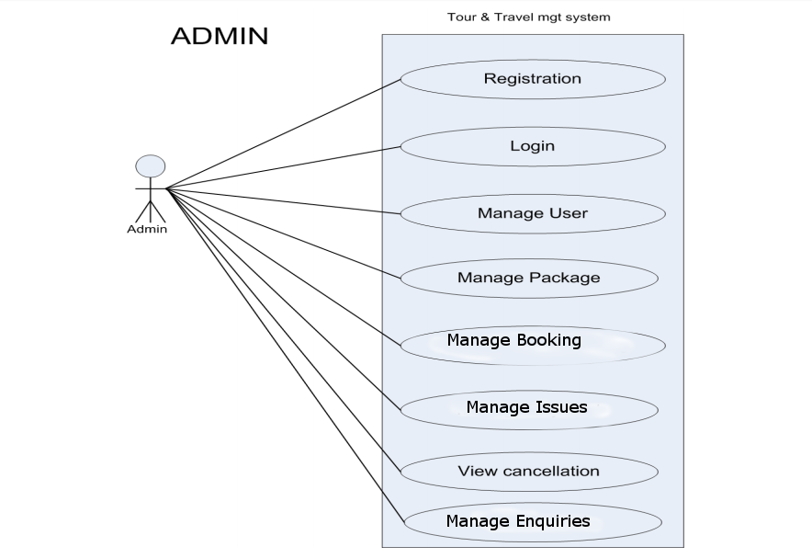

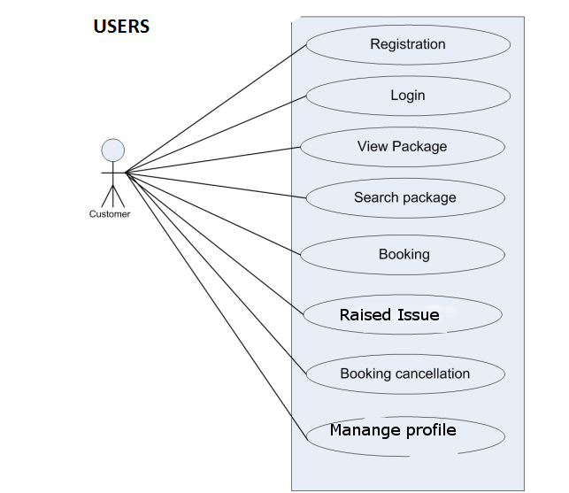

ENTITY-RELATIONSHIP Diagrams
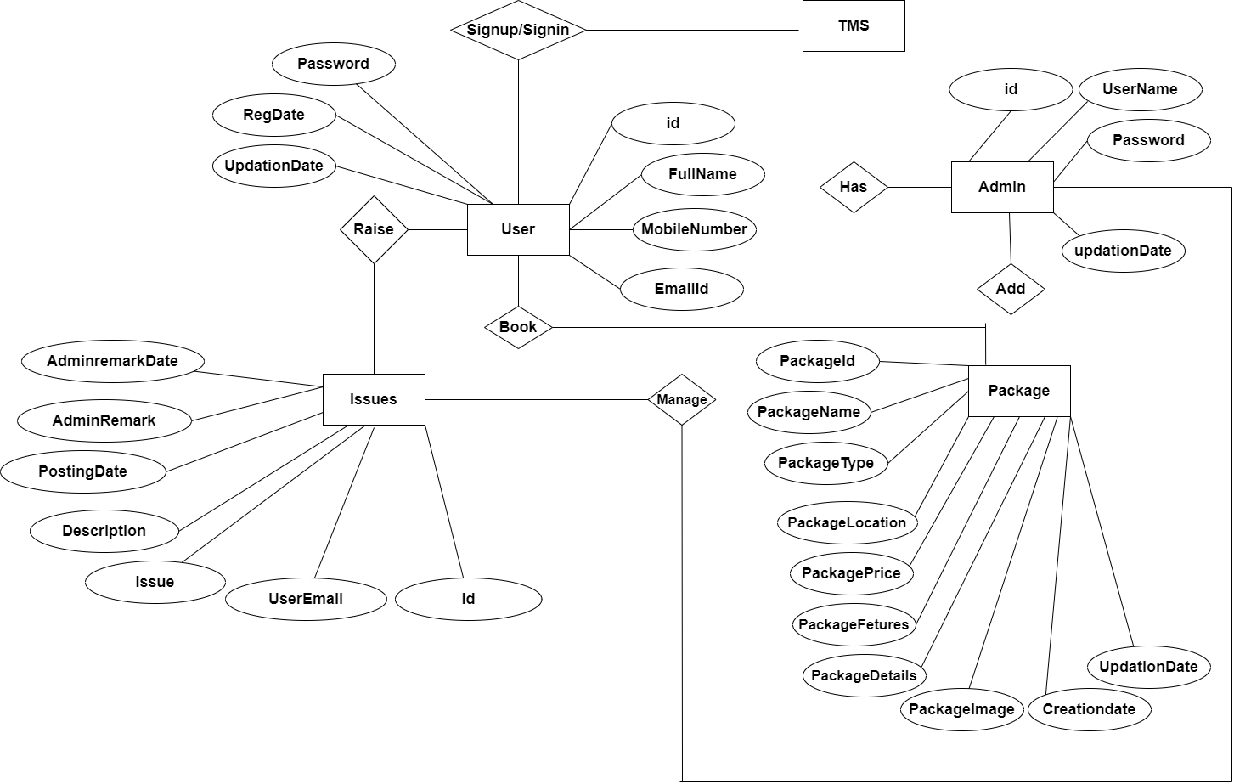

Database Design

Database tables and Structure
Admin Table: This table store the admin login details.
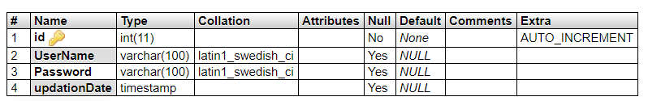
tbluser table: This table store the user personal and login details.
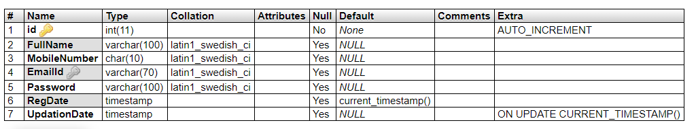
tbltourpackages table: This table store the tour package full details.
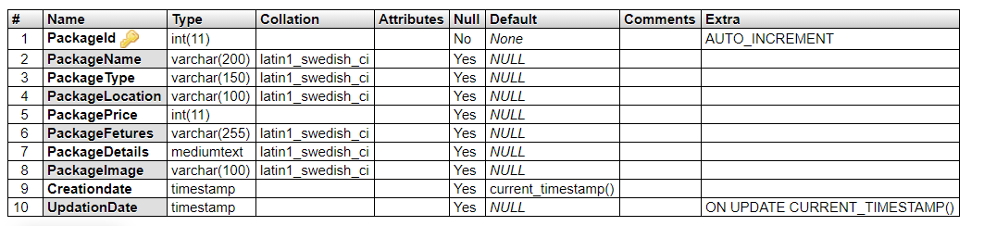
tblbooking table: This table store the user booking details.
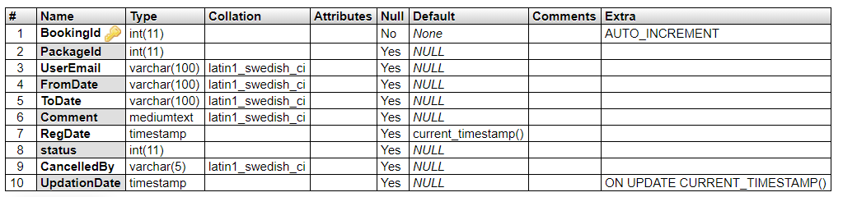
tblissues table: This table store the user issue details raised by the user.
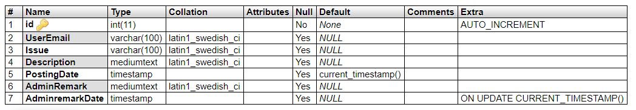

tblenquiry table: This table store the user enquiry details.
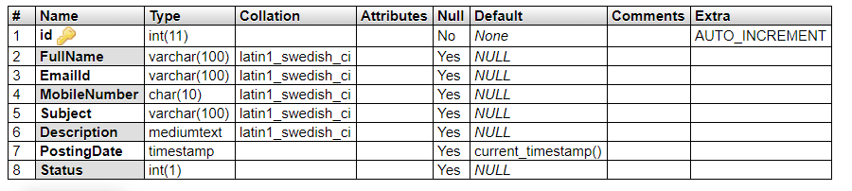

tblpages table: This table store the website pages details.
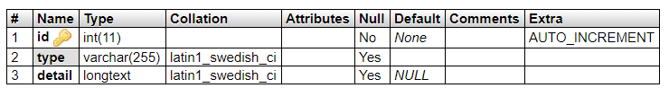

Normalization
Universal Relation:
{ id, Username, Password, updationDate, BookingId, PackageId, UserEmail, FromDate, ToDate, Comment, RegDate, status, CancelledBy, UpdationDate, FullName, EmailId, MobileNumber, Subject, Description, PostingDate, Status, Issue, AdminRemark, AdminremarkDate, type, detail, PackageName, PackageType, PackageLocation, PackagePrice, ckageFetures, PackageDetails, PackageImage, Creationdate }

Functional Dependencies:
- admin:
id ➔ UserName, Password, updationDate

- tblbooking:
BookingId ➔ PackageId, UserEmail, FromDate, ToDate, Comment, RegDate, status, CancelledBy, UpdationDate

- tblenquiry:
id ➔ FullName, EmailId, MobileNumber, Subject, Description, PostingDate, Status

- tblissues:
id ➔ UserEmail, Issue, Description, PostingDate, AdminRemark, AdminremarkDate

- tblpages:
id ➔ type, detail

- tbltourpackages:
PackageId ➔ PackageName, PackageType, PackageLocation, PackagePrice, PackageFetures, PackageDetails, PackageImage, Creationdate, UpdationDate
- tblusers:
id ➔ FullName, MobileNumber, EmailId, Password, RegDate, UpdationDate.

Normalising to First Normal Form (1NF):
To normalize these tables to the first normal form (1NF), we need to ensure that each attribute contains only atomic values, i.e., no multi-valued or composite attributes.

- R_admin:
Attributes: {id, UserName, Password, updationDate}

- R_booking:
Attributes: {BookingId, PackageId, UserEmail, FromDate, ToDate, Comment, RegDate, status, CancelledBy, UpdationDate}

- R_enquiry:
Attributes: {id, FullName, EmailId, MobileNumber, Subject, Description, PostingDate, Status}

- R_issues:
Attributes: {id, UserEmail, Issue, Description, PostingDate, AdminRemark, AdminremarkDate}

- R_pages:
Attributes: {id, type, detail}

- R_tourpackages:
Attributes: {PackageId, PackageName, PackageType, PackageLocation, PackagePrice, PackageFetures, PackageDetails, PackageImage, Creationdate, UpdationDate}

- R_users:
Attributes: {id, FullName, MobileNumber, EmailId, Password, RegDate, UpdationDate}

Each relation is now in the First Normal Form (1NF), with atomic attributes and no composite attributes, multivalued attributes, or nested relations.

Normalising to Second Normal Form (2NF):
2NF is based on the concept of Full Functional Dependency.
A relation schema R is in 2NF if it is in 1NF form and every non-prime attribute A in R is
fully functionally dependent on the primary key of R.

- R_admin:
Primary Key: id
Attributes: {id, UserName, Password, updationDate}
All non-key attributes are fully functionally dependent on the primary key, so it is already in 2NF.

- R_booking:
Primary Key: BookingId
Attributes: {BookingId, PackageId, UserEmail, FromDate, ToDate, Comment, RegDate, status, CancelledBy, UpdationDate}
Notice that PackageId and UserEmail are not fully functionally dependent on the primary key. They depend on BookingId, which is part of the composite key. Therefore, we need to split this relation into two to remove partial dependencies:

- R_booking1:
Primary Key: BookingId
Attributes: {BookingId, PackageId, FromDate, ToDate, Comment, RegDate, status, CancelledBy, UpdationDate}

- R_booking2:
Primary Key: BookingId
Foreign Key: BookingId (references R_booking1)
Attributes: {BookingId, UserEmail}
- R_enquiry:
Primary Key: id
Attributes: {id, FullName, EmailId, MobileNumber, Subject, Description, PostingDate, Status}
All non-key attributes are fully functionally dependent on the primary key, so it is already in 2NF.

- R_issues:
Primary Key: id
Attributes: {id, UserEmail, Issue, Description, PostingDate, AdminRemark, AdminremarkDate}
All non-key attributes are fully functionally dependent on the primary key, so it is already in 2NF.

- R_pages:
Primary Key: id
Attributes: {id, type, detail}
All non-key attributes are fully functionally dependent on the primary key, so it is already in 2NF.

- R_tourpackages:
Primary Key: PackageId
Attributes: {PackageId, PackageName, PackageType, PackageLocation, PackagePrice, PackageFetures, PackageDetails, PackageImage, Creationdate, UpdationDate}
All non-key attributes are fully functionally dependent on the primary key, so it is already in 2NF.

- R_users:
Primary Key: id
Attributes: {id, FullName, MobileNumber, EmailId, Password, RegDate, UpdationDate}
All non-key attributes are fully functionally dependent on the primary key, so it is already in 2NF.
We decomposed the R_booking relation to ensure that each relation contains attributes that are fully functionally dependent on the primary key. This ensures that the relations are in the Second Normal Form (2NF)

Normalising to Third Normal Form (3NF):
A relation is in the third normal form, if there is no transitive dependency for non-prime
attributes as well as it is in the second normal form. A relation is in 3NF if at least one of the
following conditions holds in every non-trivial functional dependency X –> Y.
● X is a super key.
● Y is a prime attribute (each element of Y is part of some candidate key).

- R_admin:
Attributes: {id, UserName, Password, updationDate}

- R_booking1:
Primary Key: BookingId
Attributes: {BookingId, PackageId, FromDate, ToDate, Comment, RegDate, status, CancelledBy, UpdationDate}

- R_booking2:
Primary Key: BookingId (foreign key referencing BookingId in R_booking1)
Attributes: {BookingId, UserEmail}

- R_enquiry:
Attributes: {id, FullName, EmailId, MobileNumber, Subject, Description, PostingDate, Status}

- R_issues:
Attributes: {id, UserEmail, Issue, Description, PostingDate, AdminRemark, AdminremarkDate}

- R_pages:
Attributes: {id, type, detail}

- R_tourpackages:
Attributes: {PackageId, PackageName, PackageType, PackageLocation, PackagePrice, PackageFetures, PackageDetails, PackageImage, Creationdate, UpdationDate}

- R_users:
Attributes: {id, FullName, MobileNumber, EmailId, Password, RegDate, UpdationDate}
Class Diagram
The class diagram shows a set of classes, interfaces, collaborations and their relationships.

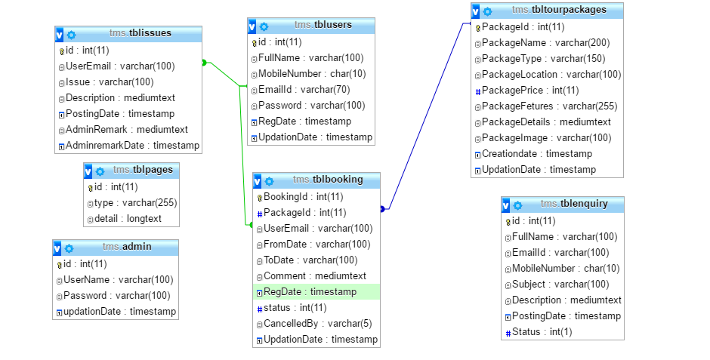

Architecture flow :( N-Tier)
N-Tier Applications can easily implement the concepts of Distributed Application Design and Architecture. The N-Tier Applications provide strategic benefits to Enterprise Solutions. While 2-tier, client-server can help us create quick and easy solutions and may be used for Rapid Prototyping, they can easily become maintenance and security night mare The N-tier Applications provide specific advantages that are vital to the business continuity of the enterprise. Typical features of a real life n-tier may include the following:
- Security
- Availability and Scalability
- Manageability
- Easy Maintenance
- Data Abstraction
The above mentioned points are some of the key design goals of a successful n-tier application that intends to provide a good Business Solution.
Definition:
Simply stated, an n-tier application helps us distribute the overall functionality into various tiers or layers:
- Presentation Layer
- Business Logic layer
- Data Link Layer
- Database/Data Store
Each layer can be developed independently of the other provided that it adheres to the standards and communicates with the other layers as per the specifications. This is the one of the biggest advantages of the n-tier application. Each layer can potentially treat the other layer as a ‘Block-Box’. In other words, each layer does not care how other layer processes the data as long as it sends the right data in a correct format.

Business Logic Layer
Presentation Layer
Request
Response
Data Link
Layer
Data Base

Fig: N-Tier Architecture

- Presentation Layer:
Also called as client layer, comprises of components that are dedicated to presenting the data to the user. For example: Windows/Web Forms and buttons, edit boxes, Text boxes, labels, grids, etc.
- Business Logic Layer:
This layer encapsulates the Business rules or the business logic of the encapsulations. To have a separate layer for business logic is of a great advantage. This is because any changes in Business Rules can be easily handled in this layer. As long as the interface between the layers remains the same, any changes to the functionality/processing logic in this layer can be made without impacting the others. A lot of client-server apps failed to implement successfully as changing the business logic was a painful process.
- Data Link Layer:
This layer comprises of components that help in accessing the Database. If used in the right way, this layer provides a level of abstraction for the database structures. Simply put changes made to the database, tables, etc do not affect the rest of the application because of the Data Access layer. The different application layers send the data requests to this layer and receive the response from this layer.
- Database Layer:
This layer comprises of the Database Components such as DB Files, Tables, Views, etc. The Actual database could be created using SQL Server, Oracle, Flat files, etc. In an n-tier application, the entire application can be implemented in such a way that it is independent of the actual Database. For instance, you could change the Database Location with minimal changes to Data Access Layer. The rest of the Application should remain unaffected.

Output Screen of Project

Home Page

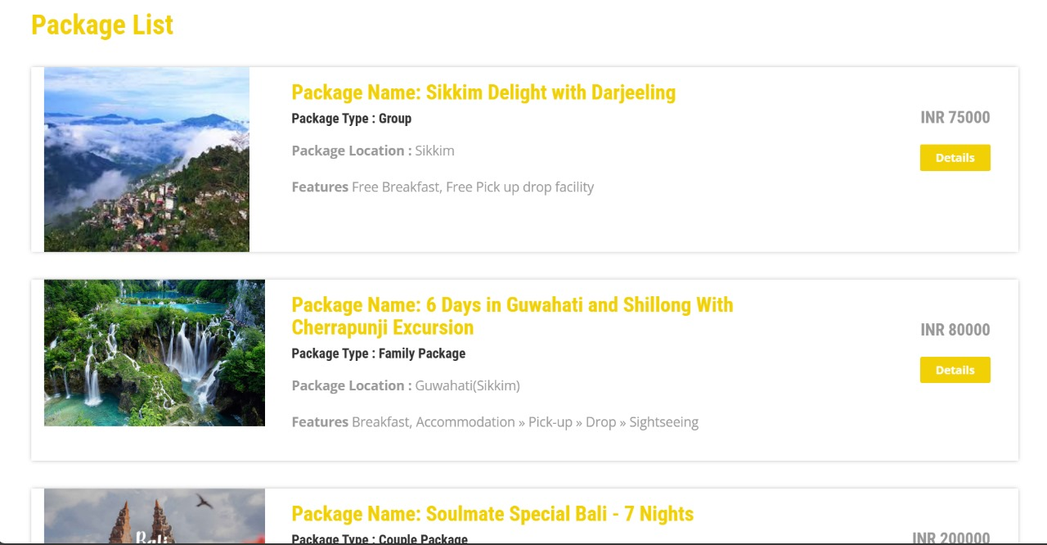
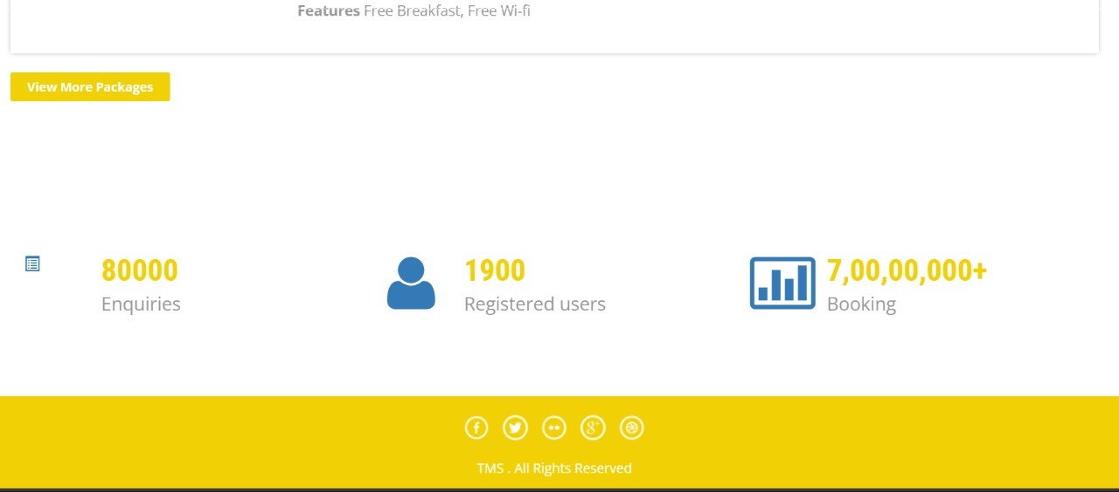
Tour Packages
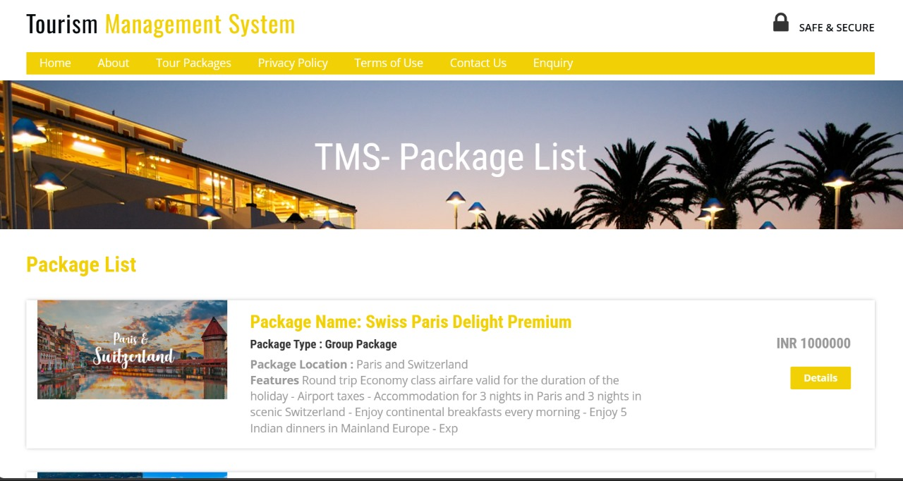
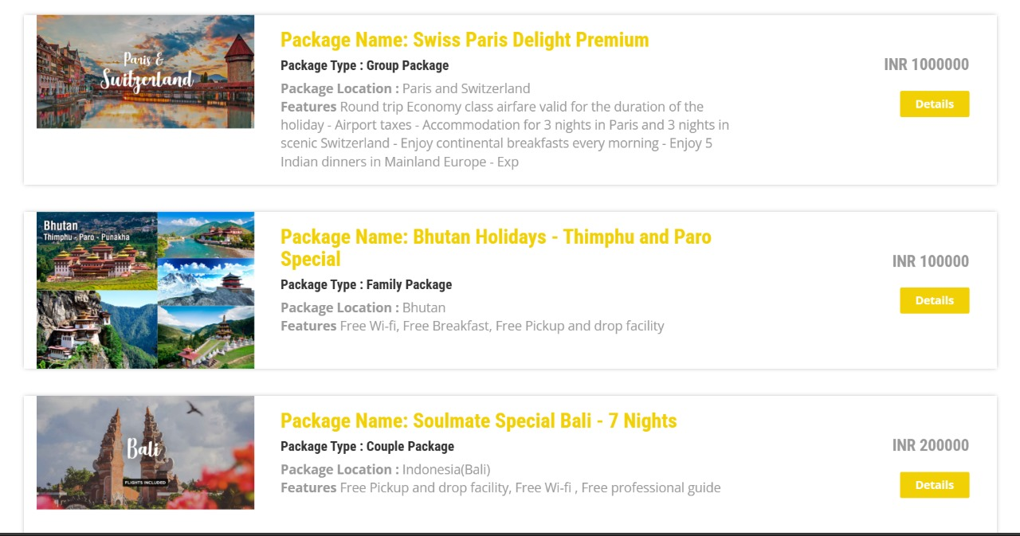

Package Details
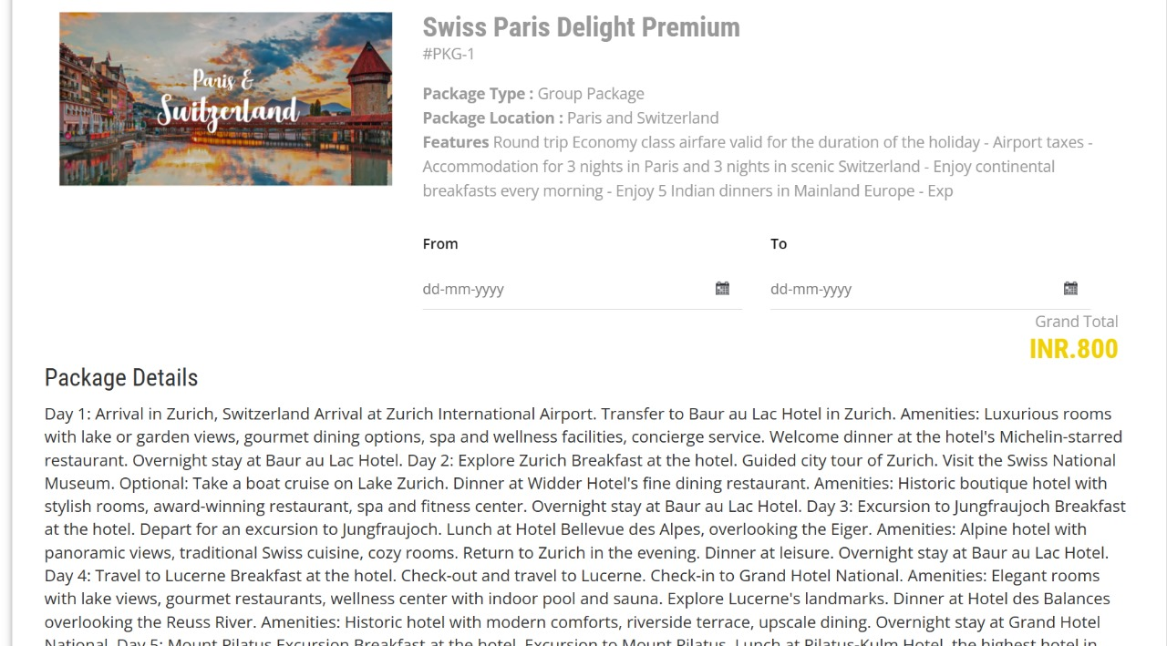
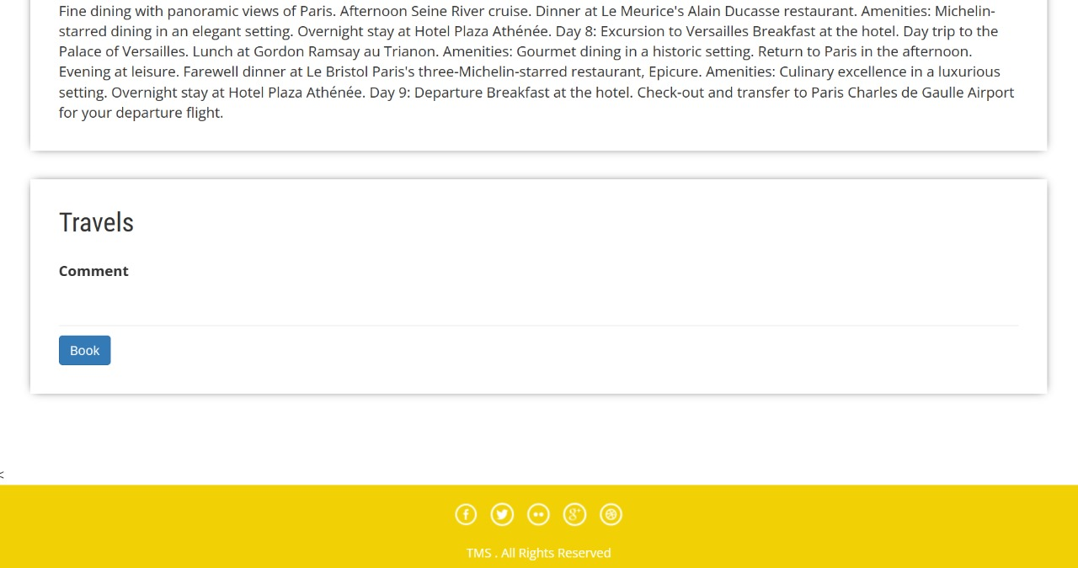

About Us
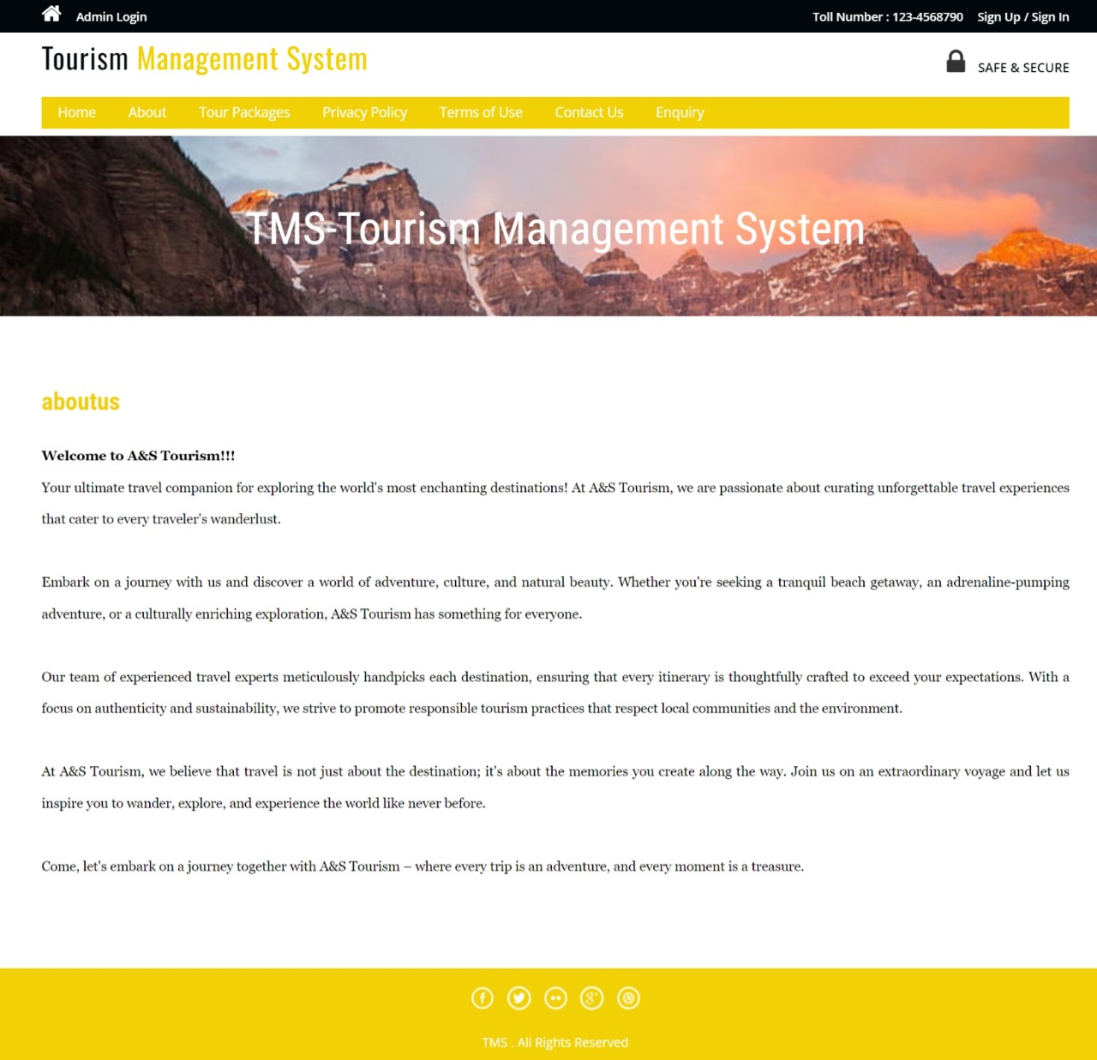
Privacy Policy
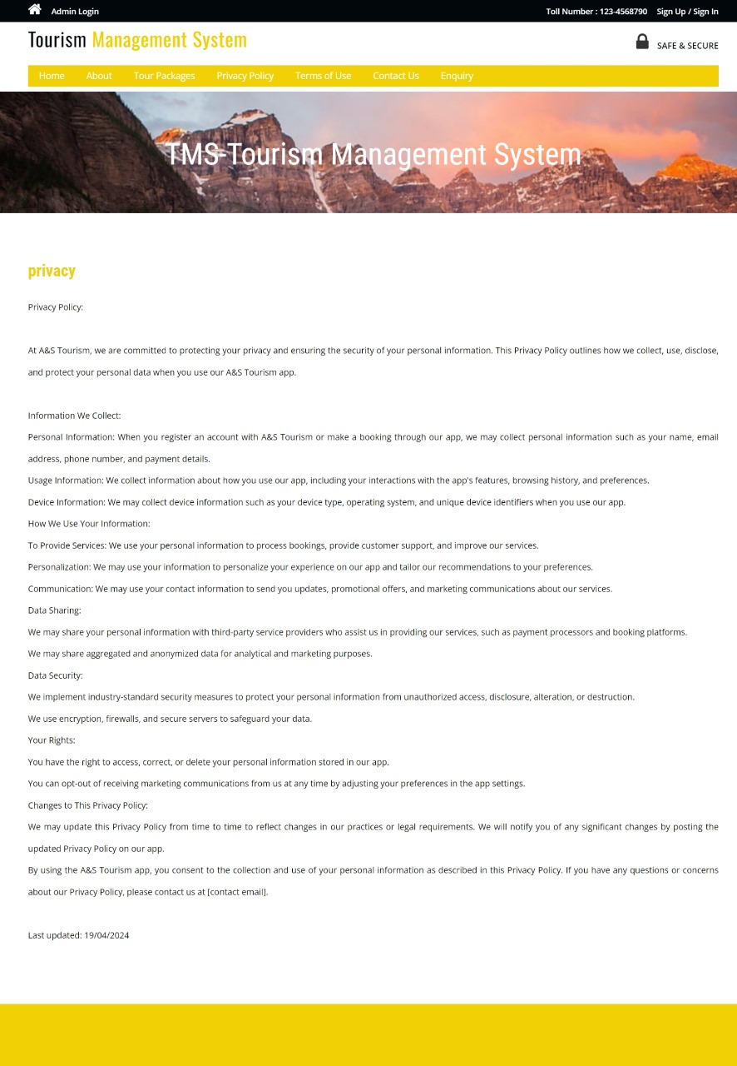
Terms of Use
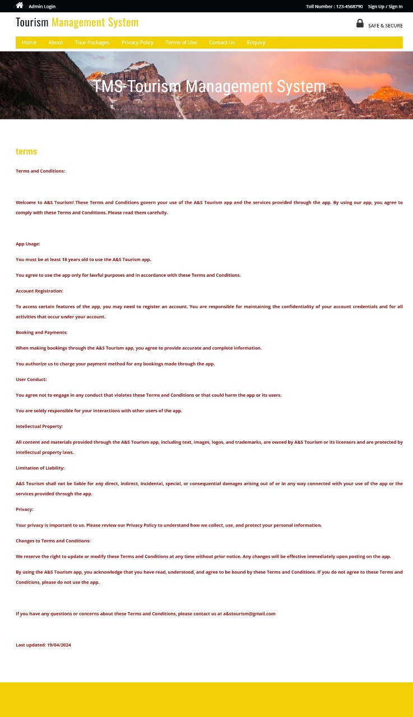

Contact Us
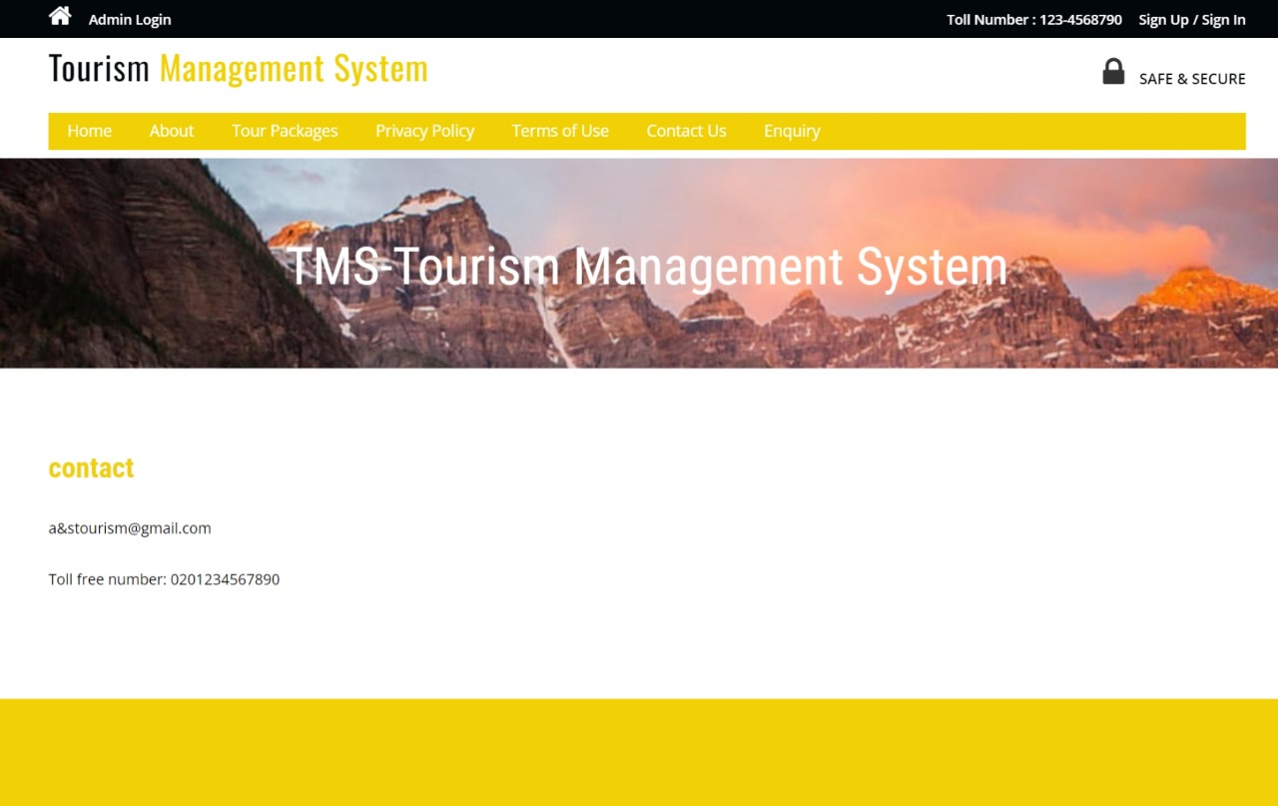

Signup
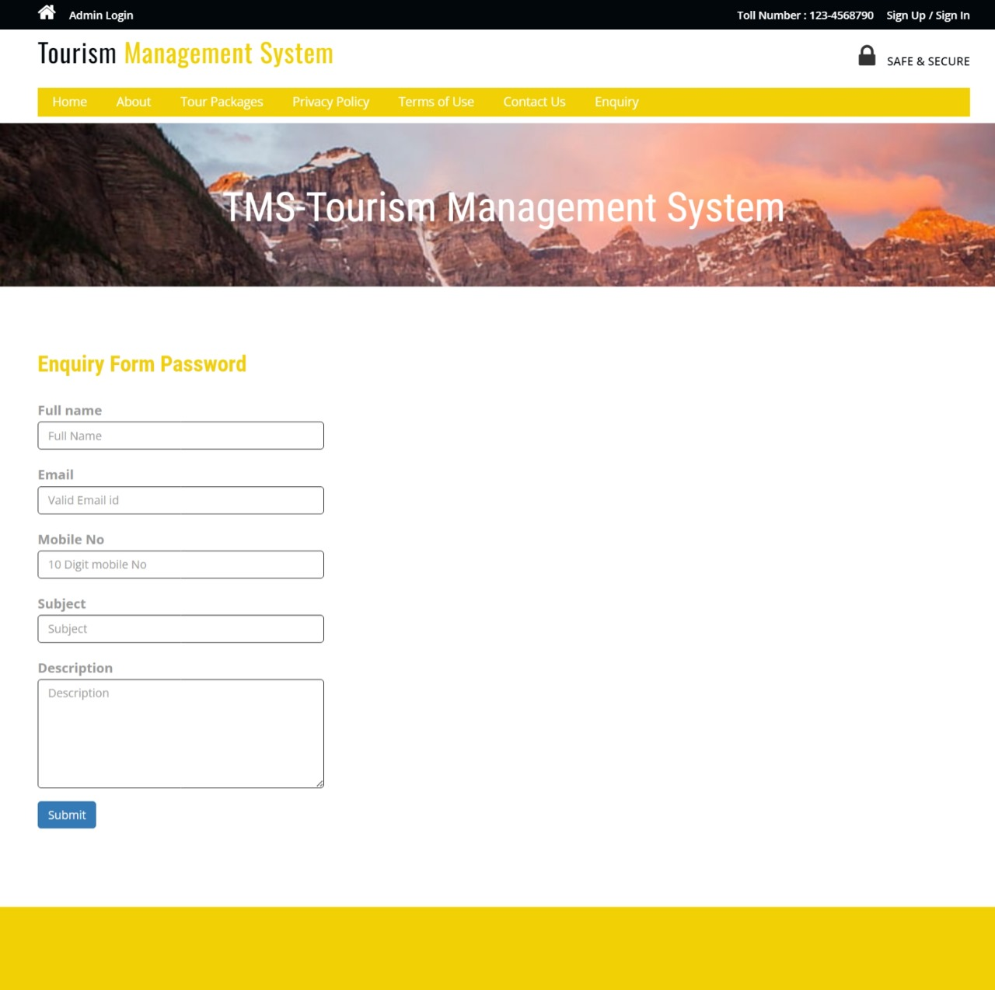
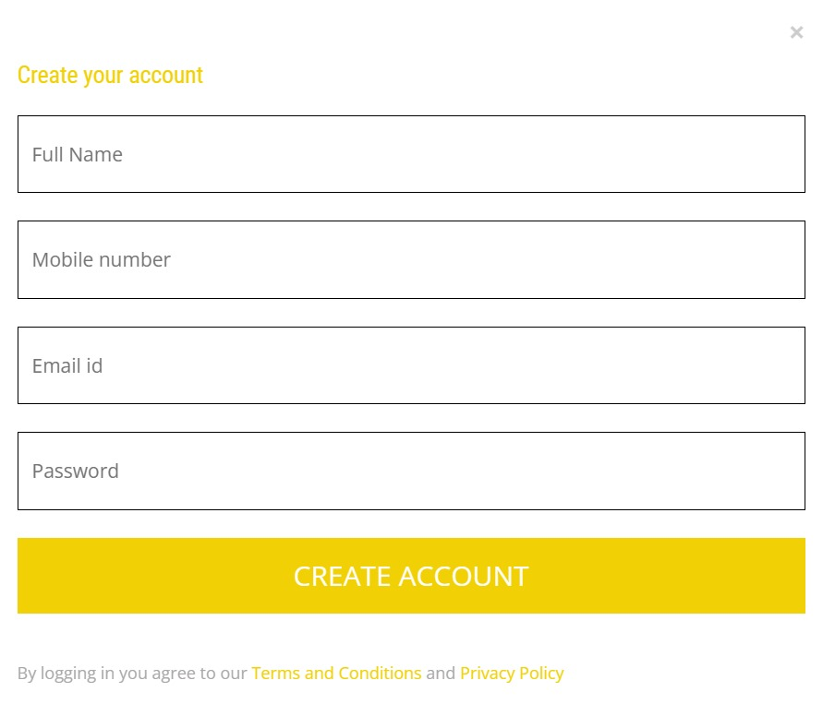

Recover Password
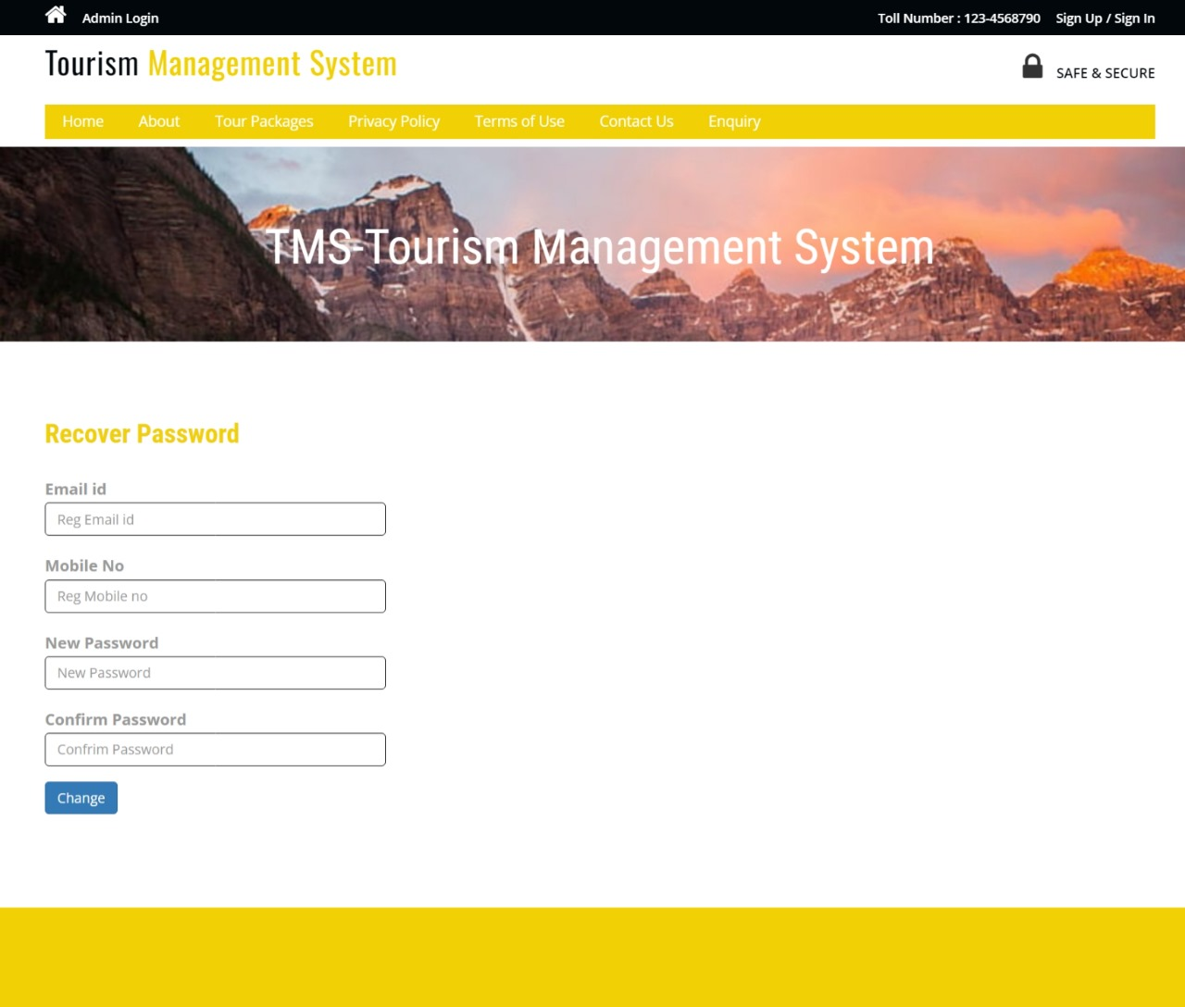

Login
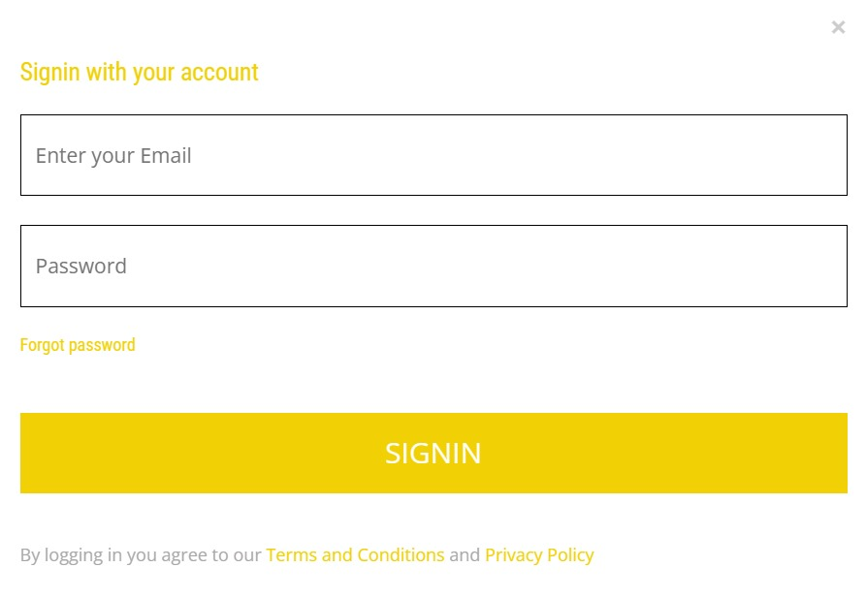

User Profile
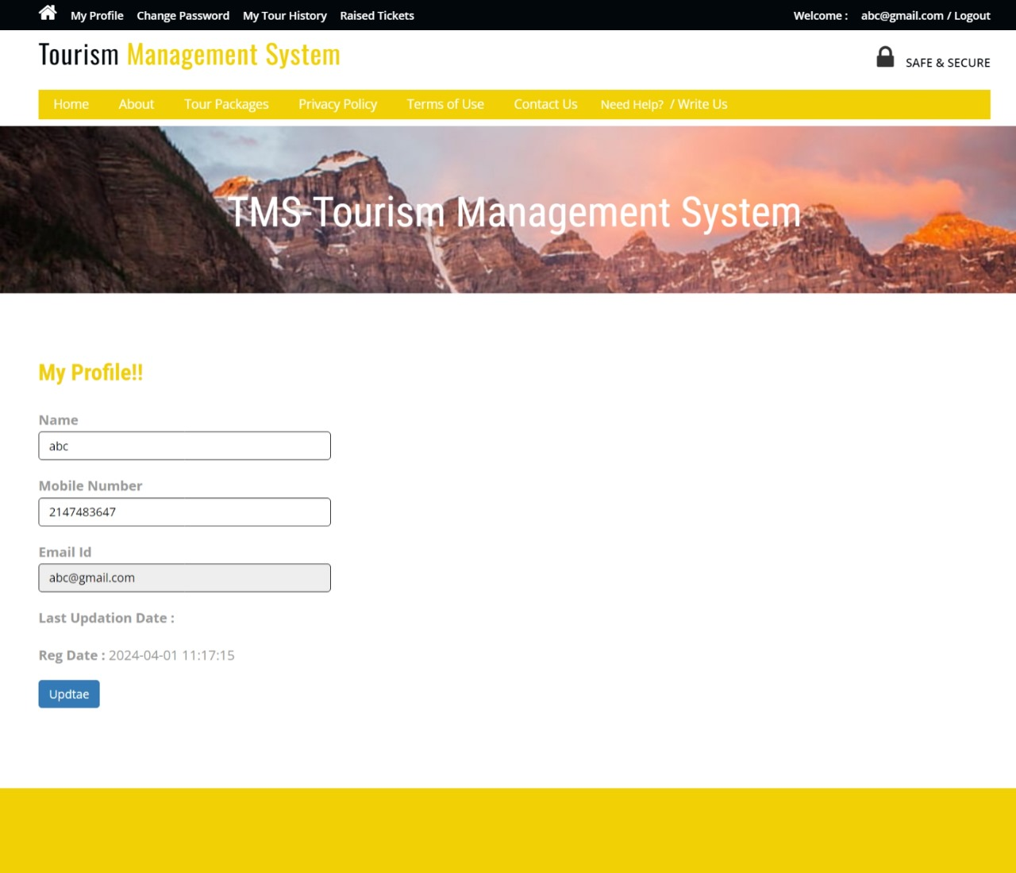

Change Password
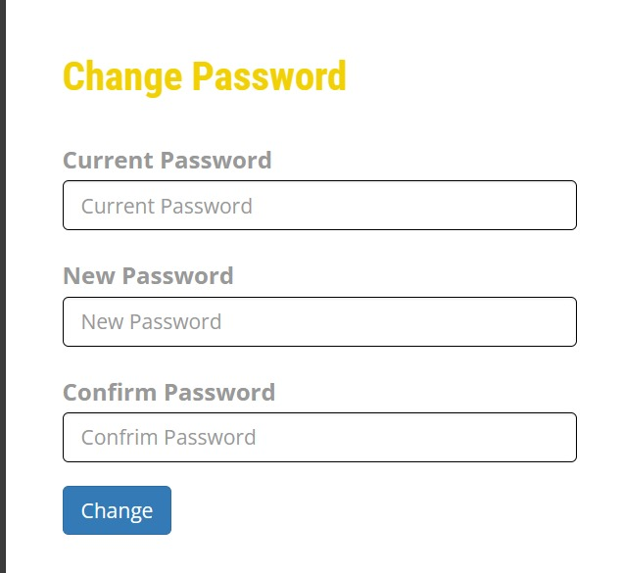

Tour History
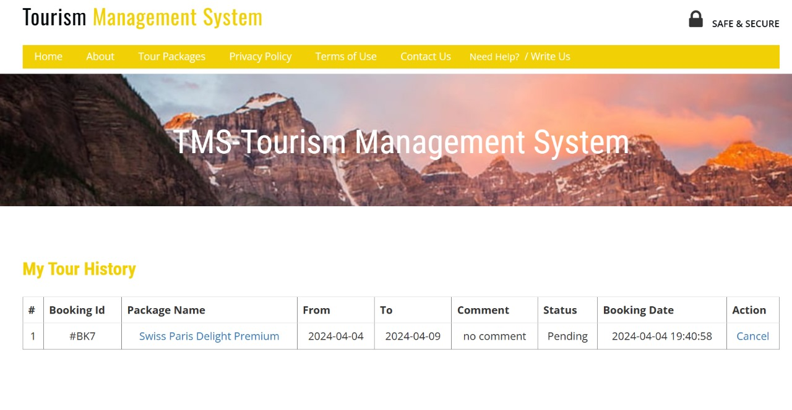

Raised Tickets
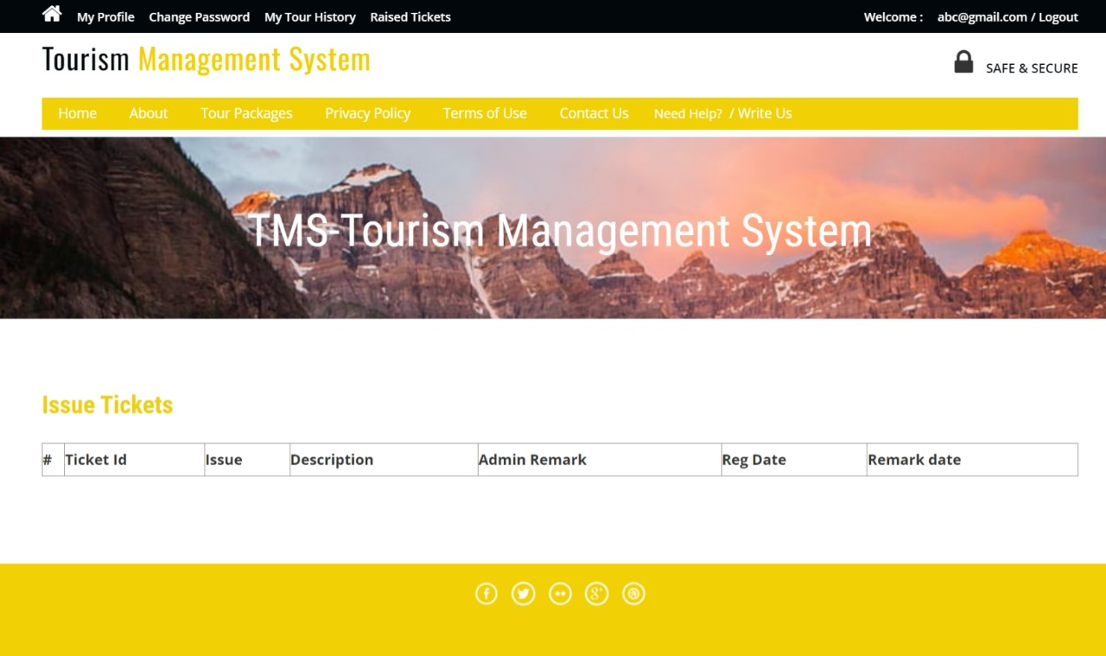

Admin Panel
Login Page
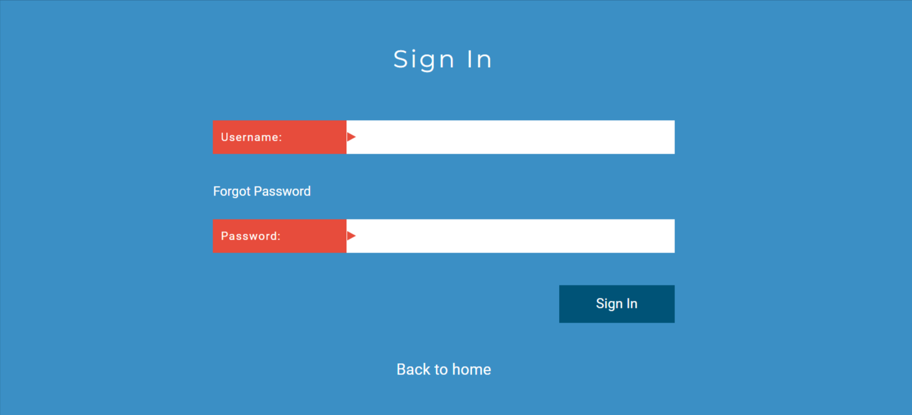

Forgot Password
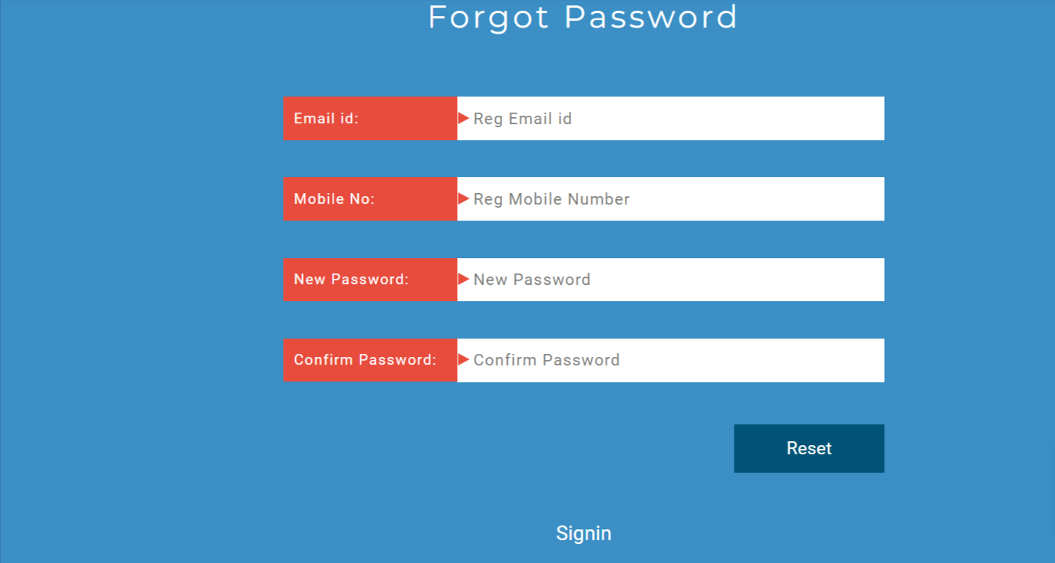

Dashboard
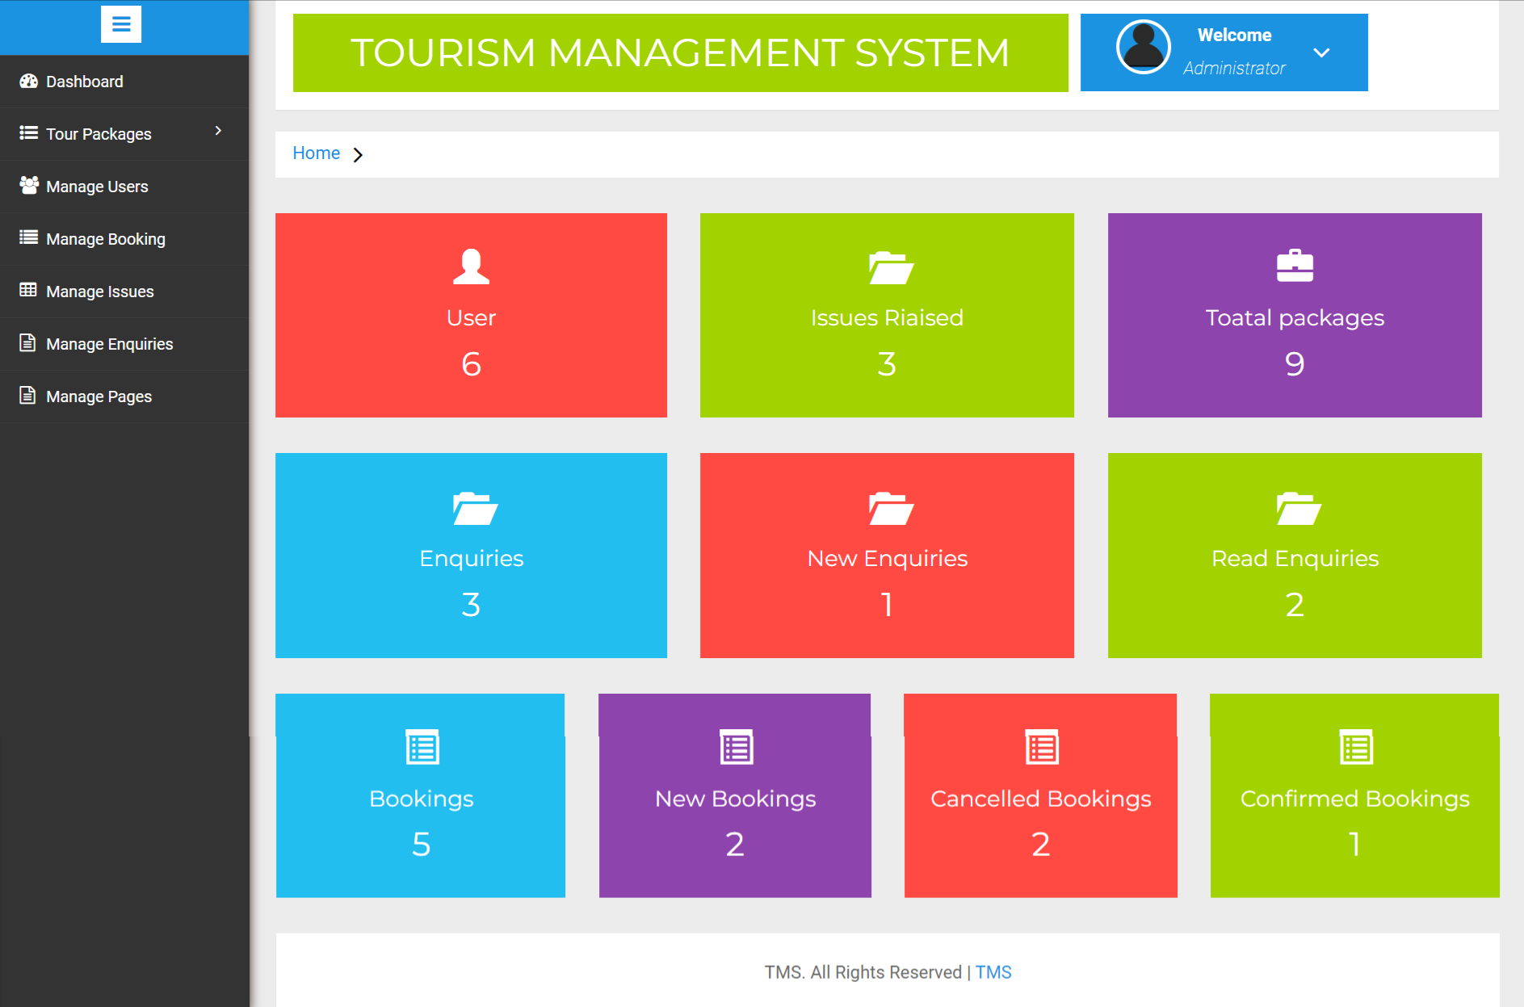

Profile
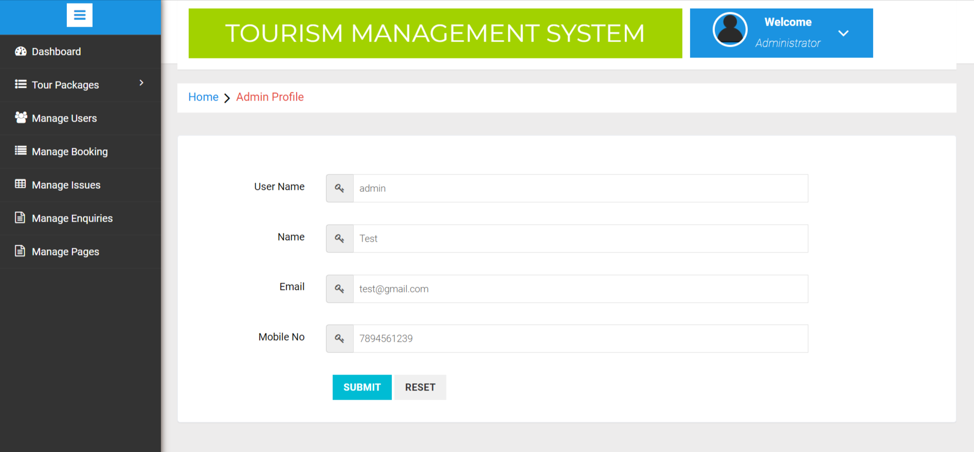

Change Password
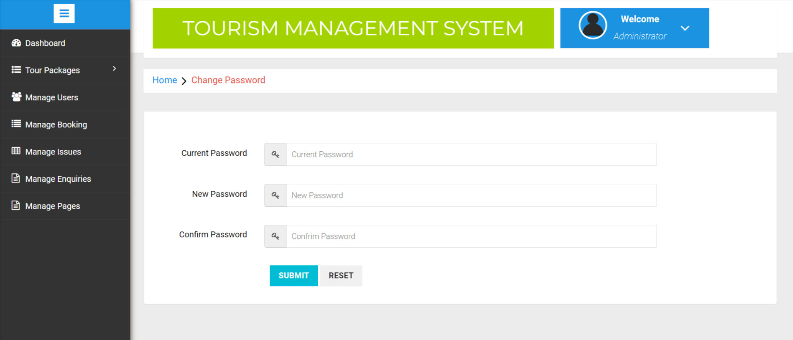
Create Package
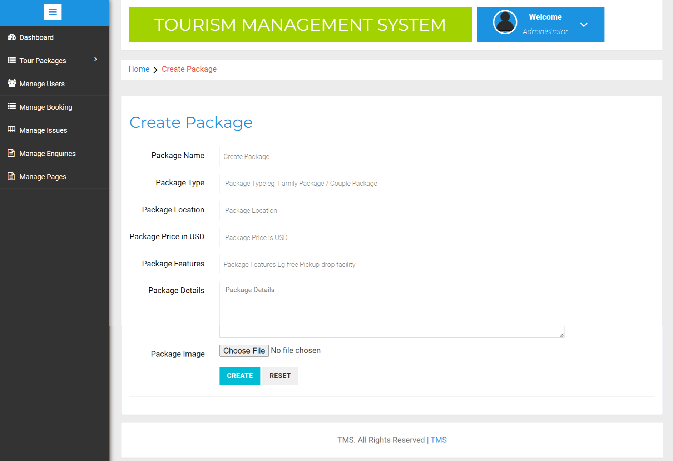
Manage Packages
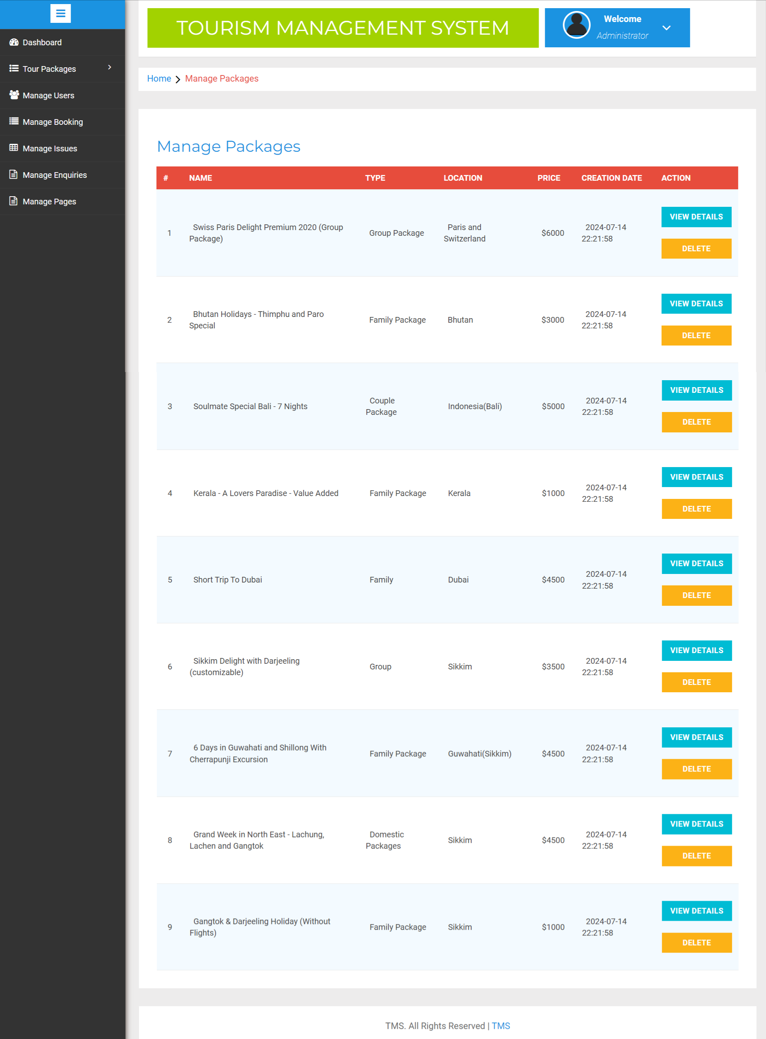

Update Package
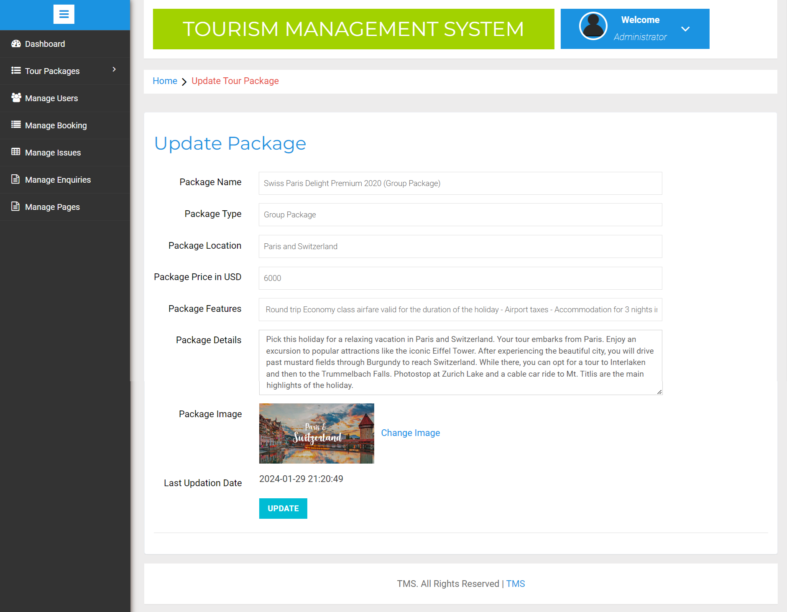
Update Package Image
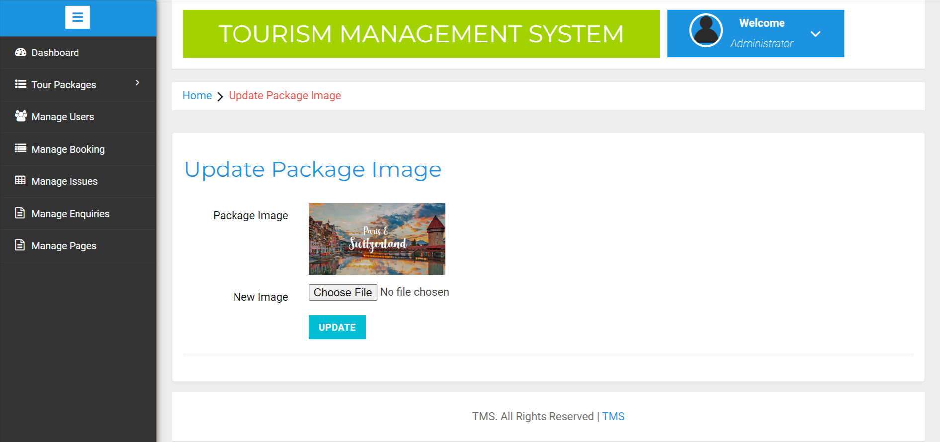
Manage User Details
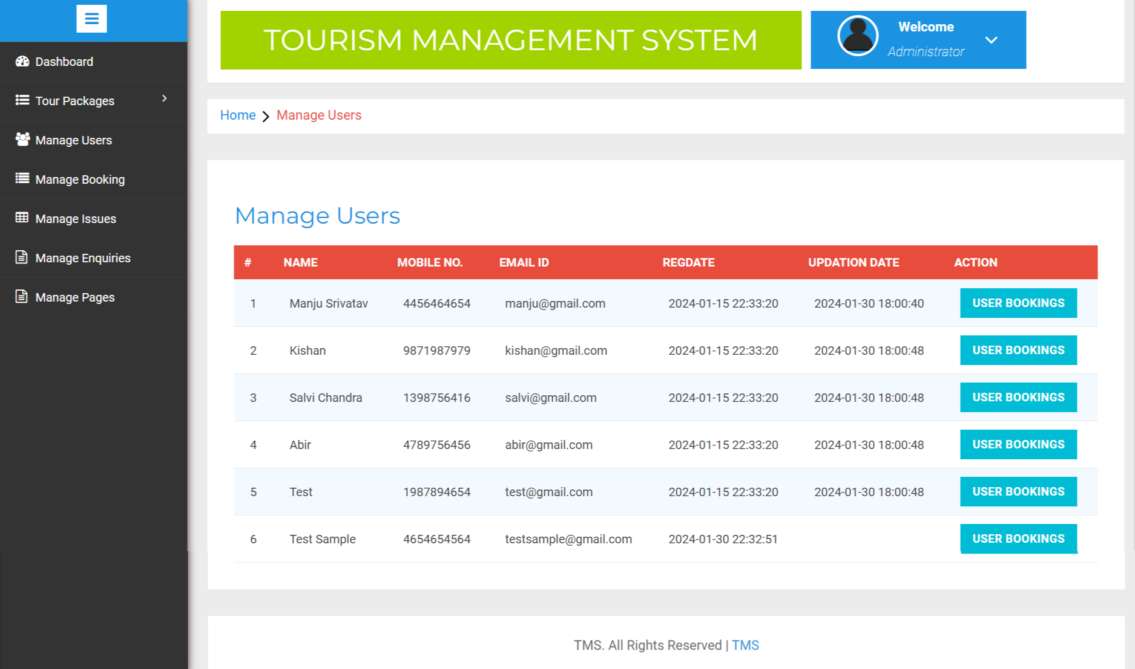
User Booking Details
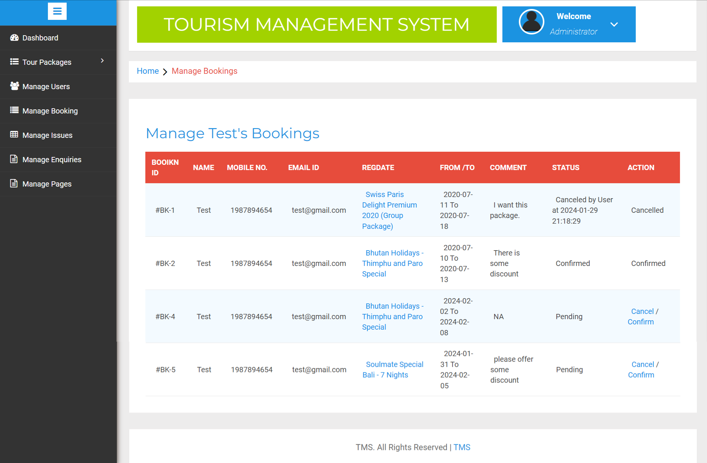
Manage Booking
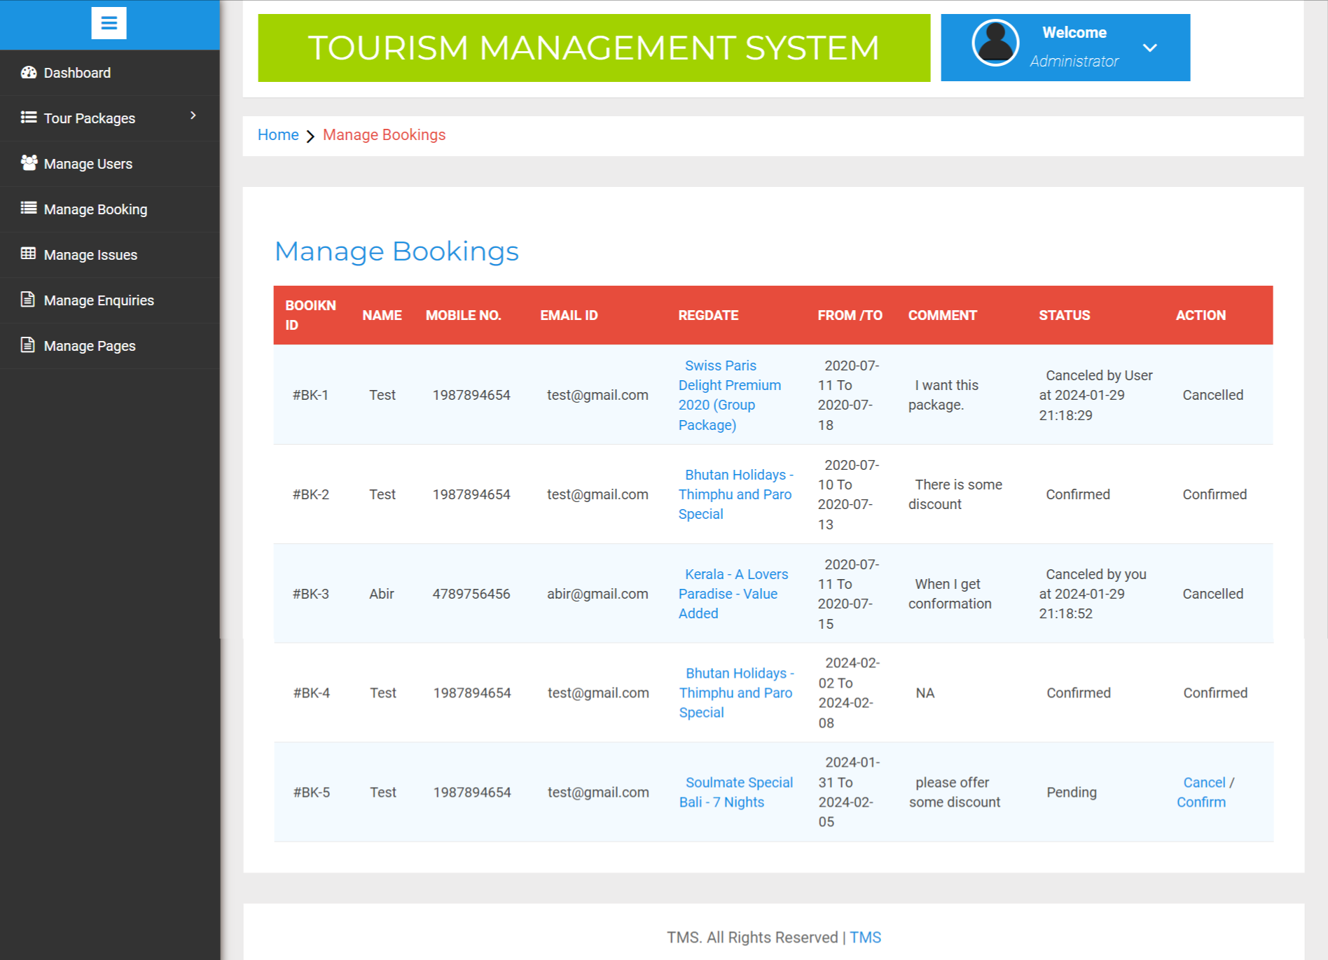

Manage Issues
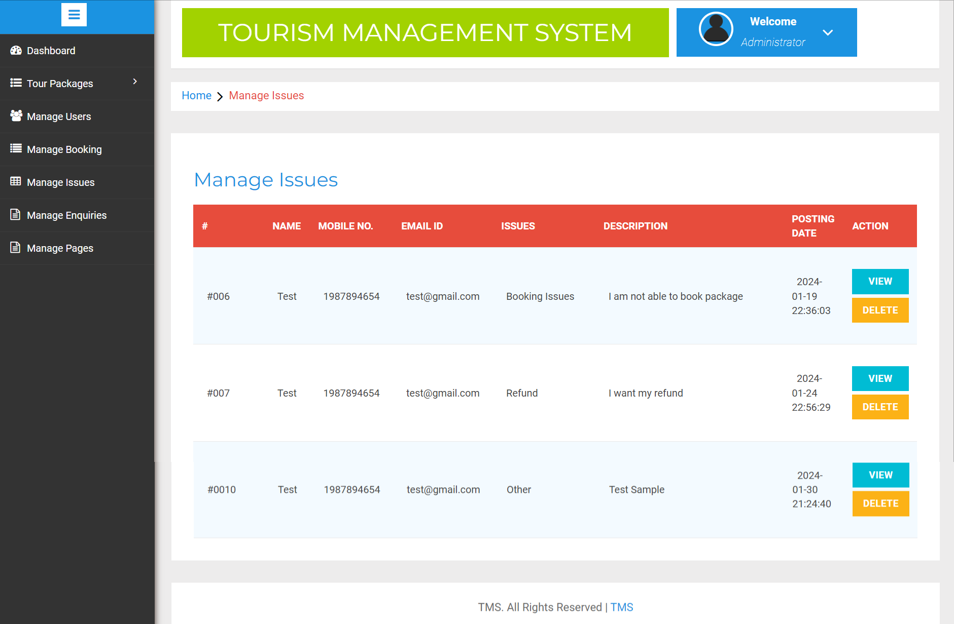

View Issues Remarks
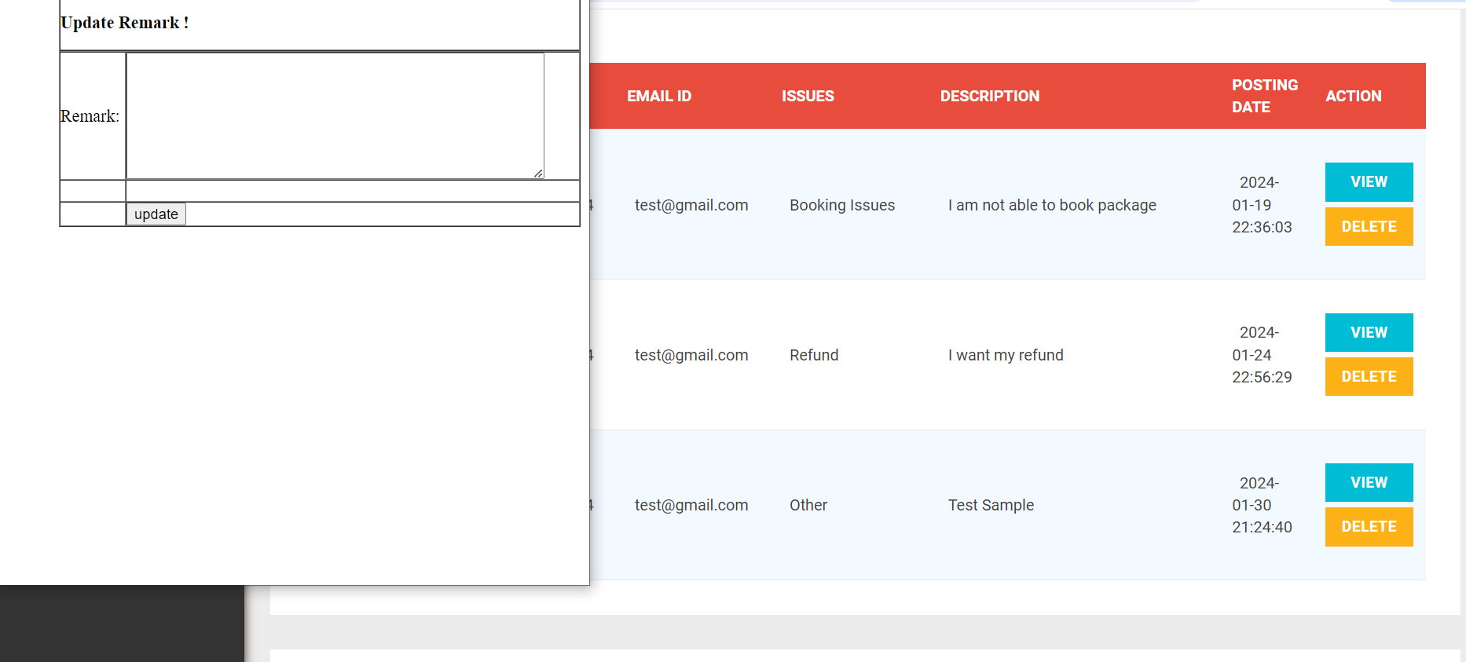

Manage Enquiries
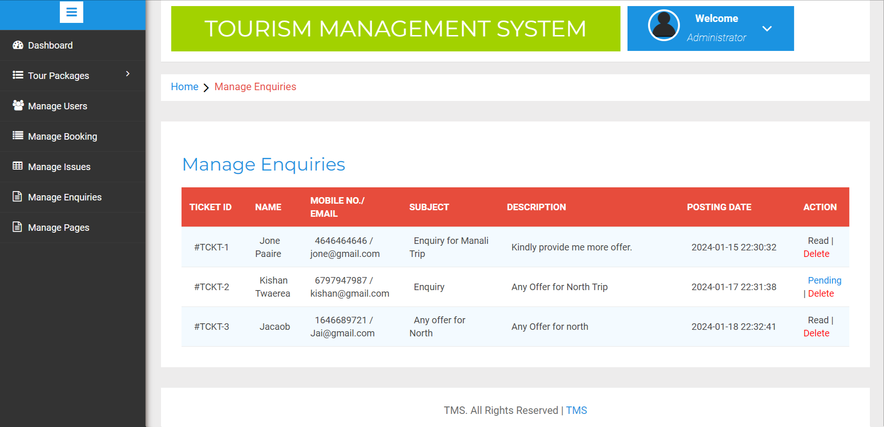

CONCLUSION

The Tourism Management System Project is designed to provide a comprehensive solution to manage and promote tourism activities. The system is built on PHP, and it is designed to facilitate various tasks related to tourism, such as reservation management, itinerary planning, tour management, and customer relationship management.

In conclusion, the project has successfully achieved its objectives of developing a reliable and efficient tourism management system that can be used by tour operators, travel agents, and other stakeholders in the tourism industry. The system has been designed to provide users with a seamless and user-friendly experience, enabling them to manage and promote tourism activities more effectively.

The system offers a range of features and functionalities that cater to the needs of different stakeholders, such as itinerary planning, booking management, customer management, and reporting. These features provide users with a holistic solution that can help them manage their tourism operations more efficiently, reduce costs, and improve customer satisfaction.

Furthermore, the project has identified some areas for improvement and future development. For instance, the system could be expanded to include features such as social media integration, mobile app integration, and advanced reporting capabilities. These enhancements can help to make the system more competitive and better meet the needs of the evolving tourism industry.

In conclusion, the Tourism Management System Project has provided a valuable contribution to the tourism industry. It has demonstrated the potential of PHP as a platform for developing reliable and efficient tourism management systems. The project has also highlighted the need for ongoing development and innovation in the tourism industry to keep pace with the changing needs and expectations of customers and stakeholders.

BIBILIOGRAPHY

- www.w3schools.com

- in.php.net

- en.wikipedia.org/wiki/PHP

4 . www.hotscripts.com/category/php/

- www.apache.org/

- www.mysql.com/click.php?e=35050

